

**Applied Physics**

**GSL-114**

**Course: BS(CS)**

**Section: 1-A**

**Semester: First Semester**

**Course Teacher: M. Umer**

**Group Members:**

Anas Ahmed (02-134212-042)

Ahmed Usmani (02-134212-045)

Zaheer Ahmed (02-134212-040)

**“PROJECT NAME”**

**“RELAY”**

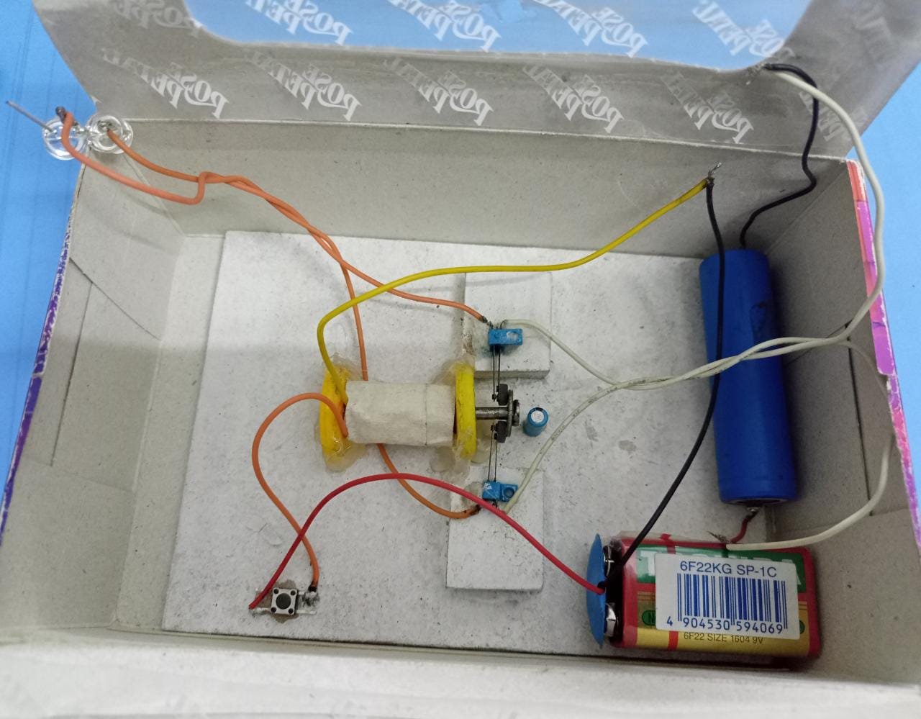

**TABLE OF CONTENTS**

1. **Introduction …………………………………………………………………………………… 1**
2. **List of Component…………………………………………………………………………… 1**
3. **Project Description & Working………………………………………………………….1**
4. **Circuit and block Diagram………………………………………………………………. 1**
5. **Uses/Applications …………………………………………………………………………….1**

1. **INTRODUCTION**

A Relay is an electromechanical device that can be used to make or break an electrical connection. It consists of a flexible moving mechanical part which can be controlled electronically through an electromagnet, basically, a relay is just like a mechanical switch but you can control it with an electronic signal instead of manually turning it on or off. Again this working principle of relayfits only for the electromechanical relay.

There are many **types of relay** and each relay has its own application, a standard, and generally used relay is made up of electromagnets which in general used as a switch. The main operation of this device is to make or break contact with the help of a signal without any human involvement in order to switch it ON or OFF. It is mainly used to control a high powered circuit using a low power signal. Generally, a DC signal is used to control the circuit which is driven by high voltage like [controlling AC home appliances with DC signals from microcontrollers](https://circuitdigest.com/home-automation-projects).

1. **LIST OF COMPONENTS**

Copper Wire.

Copper Wire Strip

Battery

3V Bulb

Battery Cell

1. **PROJECT DESCRIPTION & WORKING**

A relay is an [electromagnetic](https://www.explainthatstuff.com/magnetism.html) switch operated by a relatively small [electric](https://www.explainthatstuff.com/electricity.html) current that can turn on or off a much larger electric current.The heart of a relay is an electromagnet (a coil of wire that becomes a temporary [magnet](https://www.explainthatstuff.com/magnetism.html) when electricity flows through it).

At first we will take a 9V battery and connect that battery with the switch and from that that switch a thin wire is connected with relay because when the current is passed the relay acts as an electromechanical device and it turns on the switch which is connected with relay.

1. **CIRCUIT AND BLOCK DIAGRAM:**

The following figure shows how a Relay looks internally and how it can be constructed

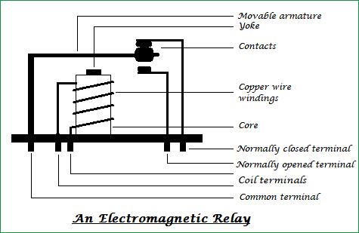

The general **circuit representation of the relay** is as shown in the figure below

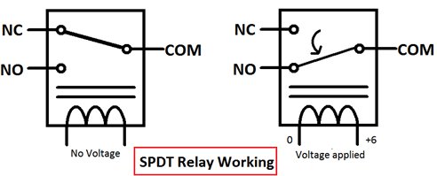

1. **USES/APPLICATIONS:**

The **applications of the relay** are limitless; its main function is to control the high voltage circuit (230V circuit AC) with the low voltage power supply (a DC voltage).

* Relays are not only used in the large electrical circuits but also used in computer circuits in order to perform the arithmetic and mathematical operations in it.
* Used to control the electric motor switches. To turn ON an electric motor we need 230V AC supply but in few cases/applications, there may be a situation to switch ON the motor with a DC supply voltage. In those cases, a relay can be used.
* Automatic stabilizers are one of its applications where a relay is used. When the supply voltage is other than the rated voltage, set of relays sense the voltage variations and controls the load circuit with the help of circuit breakers.
* Used for the circuit selection if there exists more than one circuit in a system.
* Used in Televisions. An old picture tube television’s internal circuitry works with the DC voltage but the picture tube needs a very high AC voltage, in order to turn on the picture tube with a DC supply we can use a relay.
* Used in the traffic signal controllers, temperature controllers.

**THE END**